Question/Answer Booklet

Name:

PHYSICAL EDUCATION STUDIES YEAR 11 ATAR
Semester 1 Exam

Time allowed for this paper
Reading time before commencing work: 0 minutes
Working time for paper: 2 Hours

To be provided by the candidate
Standard items: pens, pencils, eraser, correction fluid, ruler, highlighter

Important note to candidates
No other items may be taken into the examination room. It is your responsibility to ensure that you do not have any unauthorised notes or other items of a non-personal nature in the examination room. If you have any unauthorised material with you, hand it to the supervisor before reading any further.

Structure of paper:
Section | Number of questions available | Number of questions to be attempted | Marks available
Section One:
Multiple-Choice
Section Two:
Short Answer
Section Three:
Extended Answer

Multiple Choice (15 marks)

1. Which of the following is not a characteristic of capillaries?
(a) Exchange carbon dioxide and oxygen.
(b) Have thin walls.
(c) Are microscopic.
(d) Have strong elastic walls.

2. The insertion point for the triceps muscle group is located on the:
(a) Ulna.
(b) Radius.
(c) Humerus.
(d) Scapula.

3. Extension of the knee joint involves:
(a) The hamstrings and gastrocnemius coming closer together.
(b) The hamstrings and gastrocnemius moving further apart.
(c) The tibialis anterior and gastrocnemius coming closer together.
(d) The tibialis anterior and gastrocnemius moving further apart.

4. Which of the following muscle groups are antagonistic pairs?
(a) Hamstrings, soleus.
(b) Pectorals, latissimus dorsi.
(c) Trapezius, biceps.
(d) Tibialis posterior, soleus.

5. Identify the joint movement performed by a swimmer’s shoulders during a backstroke race:
(a) Adduction.
(b) Flexion.
(c) Extension.
(d) Circumduction.

6. Which of the following muscle groups are not antagonistic pairs?
- Biceps, triceps.
- Trapezius, deltoids.
- Tibialis anterior, gastrocnemius.
- Gastrocnemius, soleus.

7. Which of the following muscles does not have its insertion point located on the humerus?
- Deltoid.
- Latissimus dorsi.
- Biceps.
- Pectoralis major.

8. During the backswing phase of a football kick, the leg is drawn behind the body prior to the forward swing of the leg. When the leg is drawn behind the body, which of the following movements occurs at the hip joint?
(a) flexion
(b) extension
(c) abduction
(d) adduction

9. An athlete underwent an extensive period of anaerobic training. During this period, they ran varying distances no longer than 400m and typically at a very high intensity. Which of the following chronic adaptations would be least likely to occur?
(a) an increase in the number and size of mitochondria
(b) an increase in glycolytic enzymes
(c) an increase in ATP-PC stores
(d) an increased tolerance of lactic acid

10. A muscle directly involved in causing a segment to move is called the
(a) agonist
(b) antagonist
(c) stabiliser
(d) controller

11. The following table represents a training day for a 3000m runner.

Set | Reps | Distance | Time to complete repetition | Rest (between reps)
1 | 6 | 400m | 75 seconds | 90 seconds; jog/walk
2 | 6 | 600m | 120 seconds | 150 seconds; jog/walk

What type of training method is the athlete using?
(a) continuous
(b) fartlek
(c) interval
(d) plyometrics

12. In preparation for an upcoming event, two athletes engage in a 2km training run and both run at the same speed. Athlete A has just started training and is considered relatively unfit whilst Athlete B has been training for months and is reaching peak condition. At the 1km point of the run, which of the following statements is most likely to be correct?

(a) The cardiac output of Athlete A is likely to be significantly higher than Athlete B.
(b) Athlete A would have a lower heart rate than Athlete B due to a higher stroke volume.
(c) Athlete B would have a lower heart rate than Athlete B due to a higher stroke volume.
(d) The cardiac output of Athlete B is likely to be significantly higher than Athlete

13. During a 400m running sprint, there is a transition period in which the Anaerobic Glycolysis system takes over from the ATP-PC system as the dominant provider of ATP. This typically occurs after approximately

(a) 1-5 sec
(b) 5-10 sec
(c) 20-30 sec
(d) 30-40 sec

14. The following table represents a phase of a resistance training program for an elite rugby player.

Weight | Sets | Reps | Rest (between sets)
90% 1RM | 3 | 4-6 | 3 minutes

Which fitness component does this phase of the training program specifically target?
(a) aerobic power
(b) muscular endurance
(c) muscular strength
(d) muscular power

15. Which of the following options correctly identifies the structures of the heart?

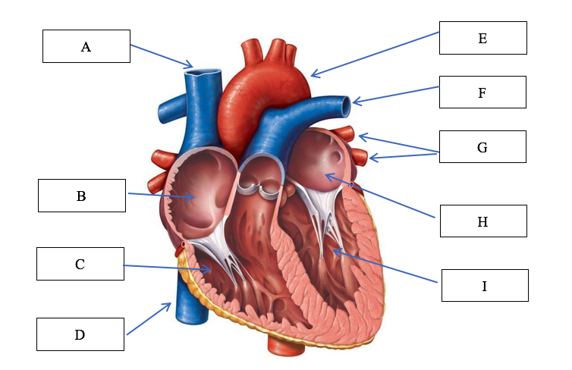

(a) A: Vena cava, B: right atrium, C: right ventricle, E: aorta, F: pulmonary vein: left atrium, G: pulmonary artery
(b) A: Vena cava, B: right atrium, C: right ventricle, E: aorta, F: pulmonary artery,
G: pulmonary vein
(c) B: left atrium, C: left ventricle, D: vena cava, E: aorta, H: right atrium, I: right ventricle
(d) B: left ventricle, C: left atrium, D: vena cava, E: aorta, H: right ventricle, I: right atrium

Short Answer
This section has fourteen (14) questions. Answer all questions. Write your answers in the spaces provided in this Question/Answer Booklet. Wherever possible, confine your answers to the line spaces provided. Use a blue or black pen (not pencil) for this section.

Question 1 (3 marks)

Identify the bones A through to C on the diagram below.
C
B
A
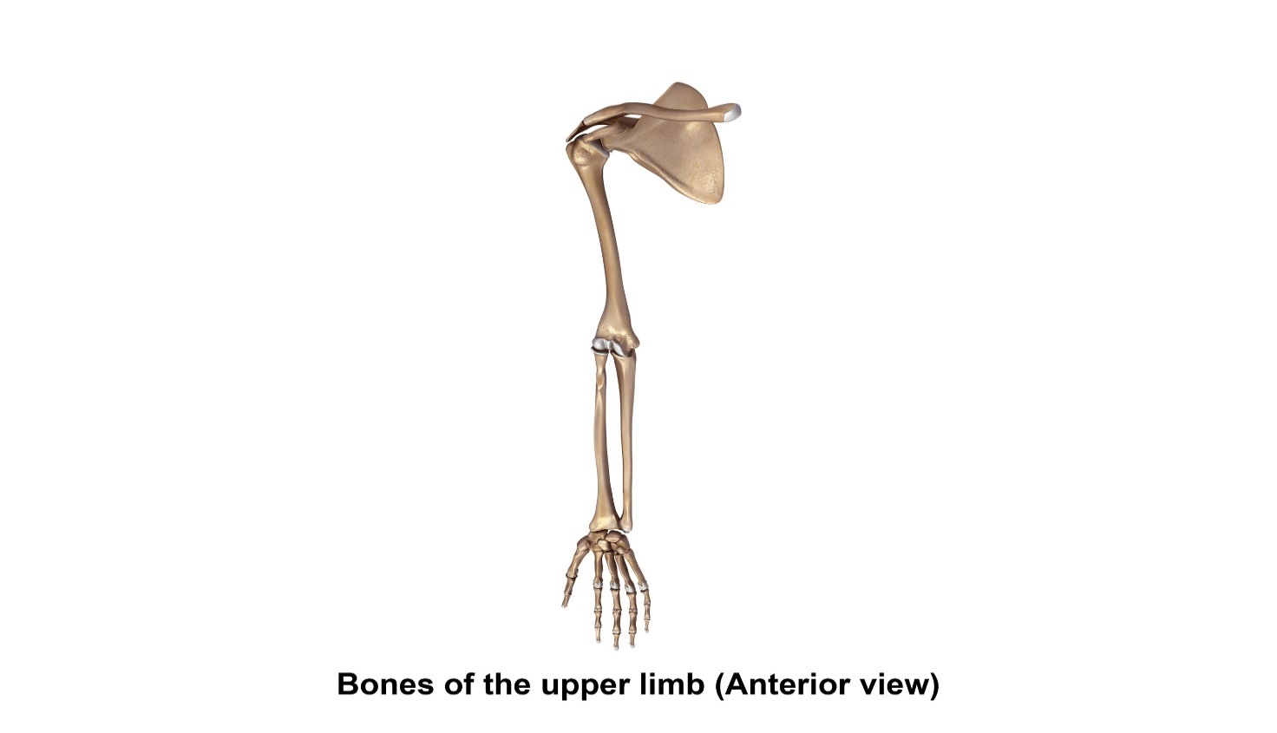

A. | B. | C.

Question 2 (4 marks)
The body consists of three types of blood vessels: arteries, veins and capillaries. Compare and contrast two (2) characteristics of veins and arteries.

Question 3 (4 marks)
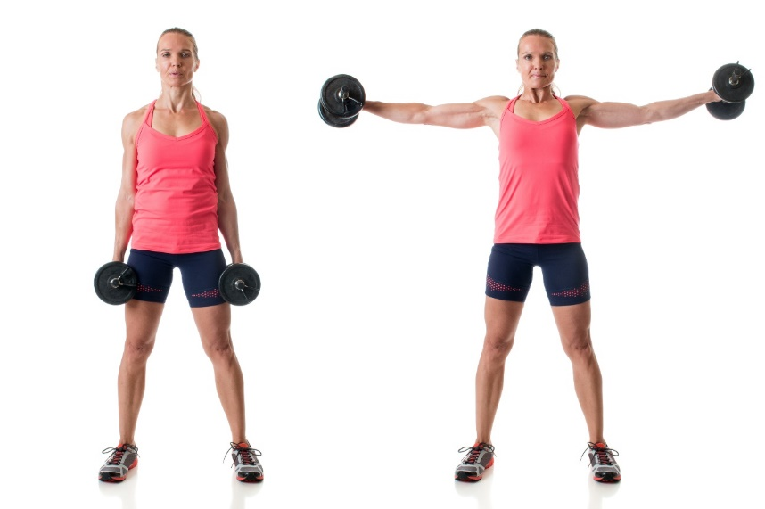
A B

In reference to the picture above, identify:

- Joint movement (from A to B)
- Agonist muscle
- Origin (of agonist)
- Insertion (of agonist)

Question 4 (6 marks)
Identify the muscles A through to F on the diagram below.
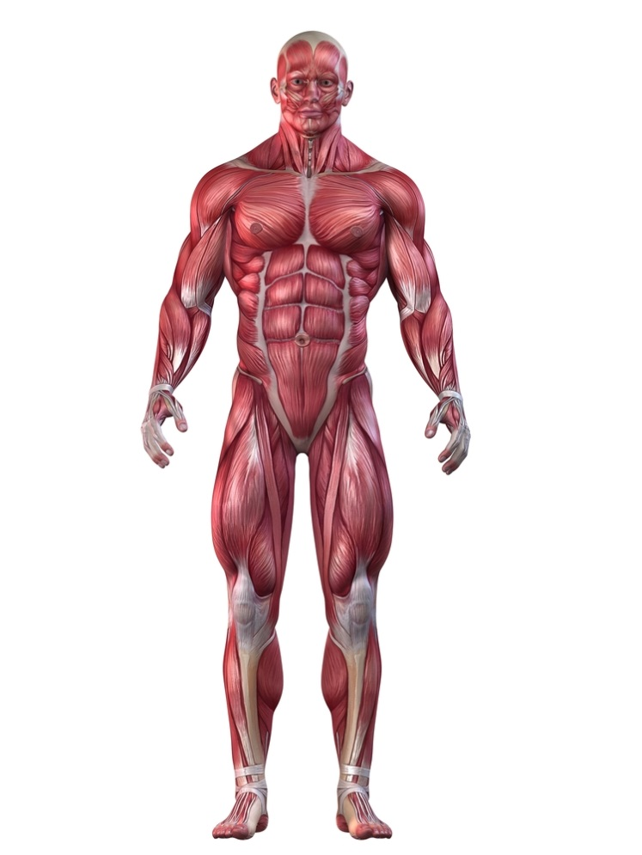
A

B
C

D

E

F

Question 5 (4 marks)
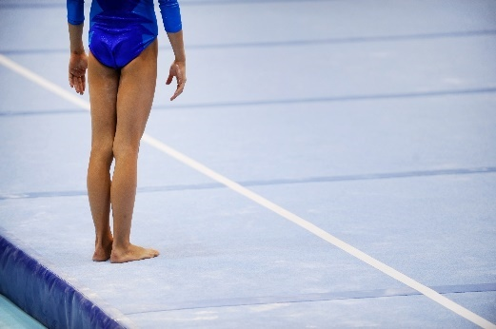
Using examples, explain two (2) types of balance a gymnast may display during a floor routine.

Question 6 (5 marks)

The following questions relate to Helen who is a 45 year old healthcare worker. She has recently started a new gym program as she is wanting to improve her muscular strength and bone density.
The image shows Helen completing a squat as part of her new gym program.

(a) When completing a squat, there are two (2) obvious joint actions occurring in the legs. Identify the joint action occurring at Helen's knee and hip during the upwards phase of the squat. (2 marks)

(b) Identify the major muscle group allowing for the movement at the knee joint to occur. (1 mark)

(c) Protection of vital organs is one function of the skeletal system. Identify two (2) other functions of the skeletal system. (2 marks)

Question 7 (5 marks)

The following graph shows the varying contributions of fats and carbohydrates during submaximal exercise.

(a) At what point does the athlete make the switch to fats as the dominant fuel supply?
(1 mark)

(b) Explain the impact this is likely to have on their performance.
(2 marks)

(c) Outline two (2) nutritional strategies the athlete could use to delay the switching to
fats as the predominant fuel source.
(2 marks)

Question 8 (10 marks)

The following graph shows the relative contributions of the different energy systems during a four (4) minute maximal intensity exercise bout.

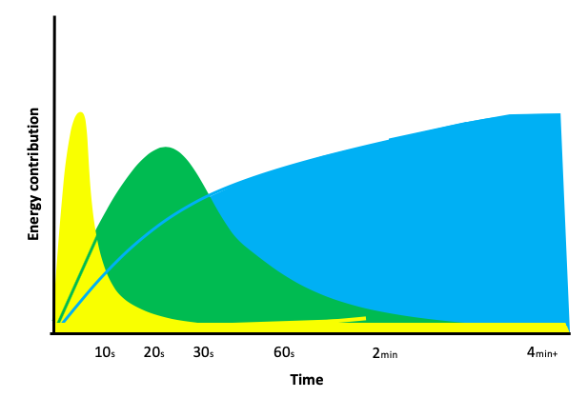
(a) At what point does the anaerobic glycolysis system become the dominant energy
provider?
(1 mark)

(b) Explain why there is a delay before the aerobic energy system becomes the
dominant provider. How does the body cater for this?
(3 marks)

(c) At the 60sec mark, identify the fuel providing most energy for ATP production.
(1 mark)

(d) Discuss the concept of energy system interplay as it relates to the event in the graph
above.
(5 marks)

Extended Answer (20 marks)

This section contains three (3) questions. You must answer two (2) of these questions. Write your answer in the spaces provided.

Spare pages are included at the end of this booklet. They can be used for planning your responses and/or additional space if required to continue an answer.
- Planning: if you use the spare pages for planning, indicate this clearly at the top of the page.
- Continuing an answer: If you need to use the space to continue an answer, indicate in the original space where the answer is continued, i.e. give the page number. Fill in the number of the question that you are continuing to answer at the top of the page.

Question 1 (10 marks)
From the point of inhalation, describe the mechanics of breathing, including pressure change and flow of oxygen through the cardiorespiratory system to supply oxygen to the working muscle/s.

Question 12 (10 marks)

In 2022, Jai Hindley made history as the first Australian cyclist to win the three-week Giro d’Italia Grand Tour. Each stage ranged from 120km to over 200km, taking up to 6 hours in length to complete. Jai’s endurance has been extensively trained to endure the stress of competition since the weekly Perth river loops and hills training rides that he used to complete as a junior.
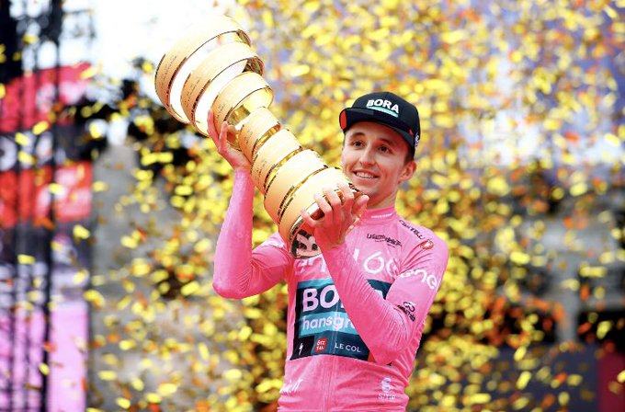

Using your knowledge of the short term cardiovascular and respiratory effects of exercise, discuss five Immediate adaptations Jai would have occurred during his race.

